PROJECT EXECUTIVE SUMMARY
(Must not exceed 1 page but does not count toward the 15-page project narrative limit.)
Title (80 characters max; strictly enforced): Text
PI and Co-PI(s): Text
Applying Institution/Organization: Text
Resource Name(s) and Number of Node Hours Requested: Text
Amount of Storage Requested: Text
Executive Summary (May use the remainder of page):
The executive summary should accurately describe the proposed research and the high-impact scientific or technical advances you will realize with the proposed INCITE allocation. Industry organizations should also summarize the potential economic or strategic business impact of the proposed research.

Insert paragraph(s).

PROJECT NARRATIVE (The narrative should not exceed 15 pages)
Visual materials, such as charts, graphs, pictures, etc., are included in the 15-page limit. References do not count toward the 15-page limit and should be after the Project Narrative. URLs that provide information related to the proposal should not be included. The 15-page limit will be strictly enforced. The Project Narrative should address the following points:

Significance of Research
Explain what advances you expect to be enabled by an INCITE award that justifies an allocation of petascale resources (e.g., anticipated impact on community paradigms, valuable insights into or solving a long-standing challenge). Place the proposed research in the context of competing work in your discipline or business. List any previous INCITE award(s) received and discuss the relationship to the work proposed. The information should be sufficient for peer review in your area of research and also appropriate for general scientific review, comparing your proposal with proposals in other disciplines. Data analytics and AI proposals may find the DOE AI for Science report valuable as a guide when writing the Significance of Research. Potential scientific or business impact is the predominant determinant for awards. This factor will be assessed by a peer review panel. This section is typically about 4 pages.

When you cite a reference, please insert a number in brackets, as shown here [1], to correspond to its number on the reference list at the end of this template. Please call out the references in numerical order and list them in the same way. The reference list will not count toward the 15-page limit.

Insert paragraph(s).

Heading 2 (optional)

Insert paragraph(s).

Heading 3 (optional)
Insert paragraph(s).

Research Objectives and Milestones
Describe the proposed research, including its goals and milestones and the theoretical and computational methods it employs. Goals and milestones should articulate simulation and developmental objectives and be sufficiently detailed to assess the progress of the project for each year of any allocation granted. Milestones should correlate with those in the milestone table. It is especially important that you provide clear connections between the project's overarching milestones, the planned computational campaign, and the compute time expected to be required for this campaign (e.g., should correlate with those in the “Use of Resources Requested”). You should also make clear any dependencies of milestones on other milestones. This section is typically about 6 pages.

If included, call out equations, tables, figures, and references in numerical order in text, such as Eqs. (1) and (2), Table 1, and Fig. 1 below.
(1)
(2)

Table 1. Table title
Column one | Column two | Column three | Column four
xxx | xxxª | xxx | xxx
xxx | xxx | xxx | xxx
ªFootnote here.

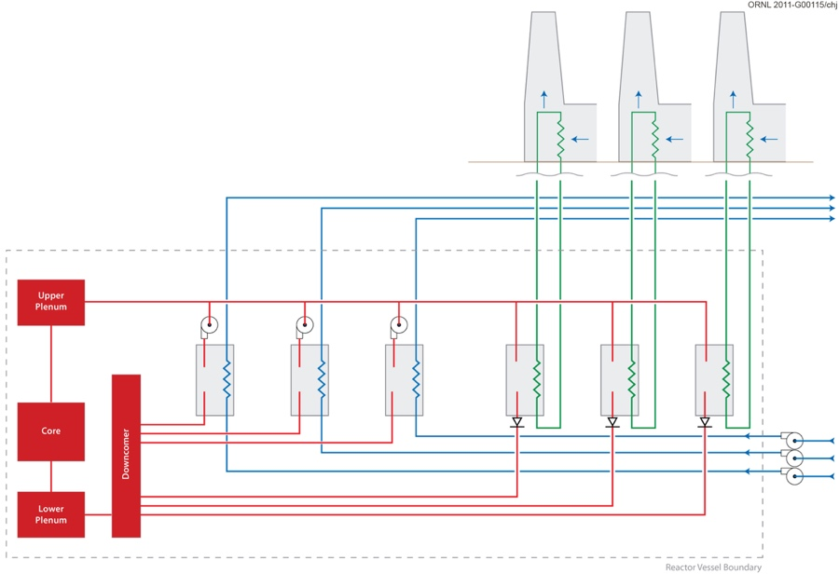
Fig. 1. Figure caption.
Heading 2 (optional)

Insert paragraph(s).

Heading 3 (optional)
Insert paragraph(s).

Computational Readiness
Proposals will be assessed on the need for, readiness to use, and reasonableness of the request for resources. Proposals should summarize the requirement(s) that best exemplifies the proposed computational work. Leadership targets in the INCITE program typically include one or both of the following categories:

• Simulation, data analytics and/or artificial intelligence (AI) projects should use a significant fraction (of the order of 20% or more) of one or more of the LCF leadership class resources; compute, memory, network or disk, for example. Parameter sweeps, ensembles, design of experiments, and other statistical methods that require large numbers of discrete or loosely coupled simulations may be considered capability-class campaigns. See the FAQs for details and qualifiers.
• Specific architectural needs that can only be met by the LCF.

This section, including the following subsections, is typically about 5 pages.

Insert paragraph(s).

Use of Resources Requested
Describe your proposed production simulations and state how the runs are tied to each of your project’s goals and milestones (Section 4, "Milestone Table"). Note that the Milestone Table should be a summary of the detailed information provided here. For the research campaign you plan to carry out, provide a

      - Description of what computations are going to be run and how they relate to the research/development objectives and milestones given above;
      - Description of processor/node use for large runs (e.g., 10,000-hour run with 100 nodes, or ten 10-hour runs with 10,000 nodes, for a 1,000,000 node-hour allocation) and for the GPU-accelerated resources, indicate which of these production simulations employ the GPUs;
      - Clear, detailed explanation as to how you calculated the requested number of node hours;
      - Summary of your anticipated annual burn rate (e.g., linear or with periods of peak usage); and
      - For projects that are in the space of data, learning or other emerging technologies, a description of how the unique LCF resources (e.g. the unique node or system architecture, inter-node parallelism, intra-node parallelism, the deep memory hierarchy including SSDs, high-bandwidth network, or data storage) enable your campaign.
Also describe the data requirements of your campaign, including:
      - Estimate and breakdown of the anticipated cumulative size of stored data, in scratch and long-term archival storage, at the end of the requested award.
      - Description of the effective lifetime of your stored data. If the lifetime varies, show the breakdown by the total size used. Explain the reason for the lifetime.
      - Description of the data, including the expected size of the data, which will be transferred into or out of the center. Describe what tools for transferring the data from external sources will be used.
      - Description of the tools for data storage, compression (reduction), and analysis that you currently use. Describe whether the tools and/or applications needed are ready or whether there are new capabilities or features that must be developed.
      - If you are intending to make any fraction of the data generated public, specify:
        - How much data and the scientific purpose;
        - What tool will be used to share the data; and
        - From where the data will be shared.
If at any point during your project the sum of your data storage needs in the scratch filesystems exceed 500 terabytes, specific justification is required.

NOTE: The LCF data management policies can be found at

ALCF: http://www.alcf.anl.gov/user-guides/data-policy
OLCF: https://www.olcf.ornl.gov/for-users/olcf-policy-guide/

Computational Approach
Provide a detailed description of your computational approach, including a discussion of the state of the art in the field. The description should also mention:
- Particular libraries required by the production and analysis software, algorithms and numerical techniques employed (e.g., finite element, iterative solver), programming languages, and other software used.
- Parallel programming model(s) used (e.g., MPI, OpenMP/Pthreads and vector intrinsics (AVX-512) for Xeon Phi; MPI, OpenMP/Pthreads, CUDA, OpenACC or AVX intrinsics for GPUs).
- Project workflow including the role of analysis and visualization; identify where the analysis will be done and any potential bottlenecks in the analysis process. Describe any analysis and/or data reduction tools used.
- Software workflow solution (e.g., pre- and postprocessing scripts that automate run management and analysis) to facilitate this volume of work.
- I/O requirements (e.g., amount, size, bandwidth, etc.) for restart, analysis, and workflow. Highlight any exceptional I/O needs.
- For projects that are in the space of data, learning or other emerging technologies, a detailed description of the efficacy of software or proposed software which will be developed to utilize the requested resources and whether that software is already installed and working on the LCF resources.

Parallel Performance
Provide direct evidence, including supporting quantitative data, for your production application’s parallel performance for the intended research campaign. Ideally, the proposing team will demonstrate proficiency with their application codes, will have generated the performance data on the LCF resource requested or another comparable resource, and these data will be representative of the entire workflow of the project proposed. If you cite work by others, explain why it is applicable here. You should use the application code you intend for the production work, not a related code. Data for sample systems not related to the intended research is undesirable. Performance benchmarking should reflect all I/O and workflow requirements. Parallel performance data in either strong or weak scaling mode must be provided. Explain how the strong or weak scaling applies to the proposed work.

NOTE: You may apply for a startup account at one of the centers to conduct performance studies.

Applications are available at

ALCF: https://www.alcf.anl.gov/science/directors-discretionary-allocation-program
OLCF: https://my.olcf.ornl.gov/project-application-new

Developmental Work
For the computational approach above, describe what, if any, development work has been carried out to date, especially on the architecture of the requested resource. Describe what development work will be executed, and when, during the proposed INCITE campaign, and an estimate of the computational resources required for this work. If applicable, identify the milestones and production simulations that are dependent on the developmental work and provide a plan for validating this developmental work.

REFERENCES
References are optional and may be structured in accordance with any style. They do not count toward the 15--page limit.
- First Author, Second Author, and Third Author, “An article in a journal,” Journal Name 32(4): 46–52.
- First Author and Second Author, Report Title, Report Number, Publishing Organization or Agency, City, State, 2013.
- First Author et al., “Chapter Title,” Book Title, Publisher, City, State, 2011.
- Corporate or Agency Author, Book Title, Publisher, City, State, 2012.

Personnel Justification AND MANAGEMENT PLAN

(Does not count toward the 15-page project narrative limit.)

PERSONNEL JUSTIFICATION
What personnel are already in place and what are their roles on the project? If applicable, describe (i) personnel that will be hired for the project in the future and their responsibilities and (ii) potential personnel turnover that may occur during the project and a strategy for replacing them. The INCITE program welcomes proposals from individual PIs or teams of collaborators.

Insert paragraph(s).
- Text
- Text

mANAGEMENT PLAN
Describe the project’s leadership team and how decisions are made to allocate time to individuals or, for proposals with multiple collaborating teams, subgroups within the project. Describe the focus of each individual or subgroup. Successful proposals will include a management plan that conveys to reviewers the interrelationship between subgroups and how the sum of the parts will lead to scientific discovery or engineering solutions that are the overarching goal of the project. Also identify points of contact who will provide updates on the status of the work including publications, awards, and highlights of accomplishments.
Insert paragraph(s).

[Refer to the guidelines for instructions in preparing the proposal. Table does not count toward project narrative page limit.]
Proposal Title (exactly as it appears on submission): Insert Text
Year 1 Total number of node-hours for Year 1: Insert Text
Milestone: | Details (as appropriate): | Dates: | Status:  (renewals only)
Insert Text | Resource: Insert Text Node-hours: Insert Text  Production size runs (number of nodes): Insert Text  Filesystem storage (TB and dates): Insert Text  Archival storage (TB and dates): Insert Text  Software Application: Insert Text  Tasks: Insert Text  Dependencies: Insert Text | Insert Text | Insert Text
Insert Text | Resource: Insert Text Node-hours: Insert Text  Production size runs (number of nodes): Insert Text  Filesystem storage (TB and dates): Insert Text  Archival storage (TB and dates): Insert Text  Software Application: Insert Text  Tasks: Insert Text  Dependencies: Insert Text | Insert Text | Insert Text
Year 2 (if appropriate) Total number of node-hours for Year 2: Insert Text
Insert Text | Resource: Insert Text Node-hours: Insert Text  Production size runs (number of nodes): Insert Text  Filesystem storage (TB and dates): Insert Text  Archival storage (TB and dates): Insert Text  Software Application: Insert Text  Tasks: Insert Text  Dependencies: Insert Text | Insert Text | Insert Text
Year 3 (if appropriate) Total number of node-hours for Year 3: Insert Text
Insert Text | Resource: Insert Text Node-hours: Insert Text  Production size runs (number of nodes): Insert Text  Filesystem storage (TB and dates): Insert Text  Archival storage (TB and dates): Insert Text  Software Application: Insert Text  Tasks: Insert Text  Dependencies: Insert Text | Insert Text | Insert Text

PUBLICATIONS RESULTING FROM INCITE AWARDS

(Does not count toward project narrative page limit.)
Provide a list of publications, including DOIs when available, resulting from previous INCITE awards to this project team for work related to the proposal under consideration. Only those publications that include an acknowledgement to INCITE and/or the LCF may be included. This list may not be used in lieu of references in the project narrative. If applicable, list the citation both here and in the project narrative.

References must be single-column format, 11 point, Arial or Times New Roman.

Curriculum Vitae (2-page limit)
PI NAME
Contact Information

Professional Preparation
PhD
MS
BS

Appointments
2010–present
2001–2010
1990–2001

Five Publications Most Relevant to This Proposal
- Publication most relevant to this proposal
- Publication most relevant to this proposal
- Publication most relevant to this proposal
- Publication most relevant to this proposal
- Publication most relevant to this proposal

Research Interests and Expertise
Insert paragraph(s).

Synergistic Activities
- Text
- Text
- Text
- Text
- Text

Collaborators (past 5 years including name and current institution)
Collaborator name, current institution
Collaborator name, current institution

