RENEWAL NARRATIVE (THE NARRATIVE SHOULD NOT EXCEED 14 PAGES)

Visual materials, such as charts, graphs, pictures, etc., are included in the 14-page limit. References do not count toward the 14-page limit and should be after the Renewal Narrative. URLs that provide information related to the proposal should not be included. The 14-page limit will be strictly enforced. The Renewal Narrative should address the following points:

PROJECT ACHIEVEMENTS
The project achievements should address the points described below. This section is typically about 10 pages.
Insert paragraph(s).

Significance of Accomplishments to Date
Explain what advances you accomplished through the INCITE award (impact on community paradigms, valuable insights into or solving a long-standing challenge, etc.). Place the proposed research in the context of competing work in your discipline or business. Reiterate the milestones of your proposal and discuss the accomplishments (planned or unplanned) achieved this year relative to those milestones and allocation use (Section 1.a.ii). Summarize the impact of the results achieved: What conclusions can be drawn, and what is solved because of these results? What new and follow-on investigations have these results motivated?
Insert paragraph(s).

Allocation Use
Summarize your project's allocation use to date this year: percent of allocated core-hours used on each platform, job size distribution, number of users, etc. Associate the resource use with particular results where possible. Also summarize your project's projected use from now until the end of December (i.e., end of current allocation year): anticipated percent of allocated core-hours used on each platform, job size distribution, etc. Associate this resource usage with anticipated results. Do you expect your usage to be evenly distributed throughout the remainder of this year? If not, explain.
Insert paragraph(s).

Application Parallel Performance
Summarize the performance (percent of peak, scalability) of your project's simulation tools used in the allocations this year. What progress was made in improving the application's performance on this architecture? What challenges (if any) remain? List the technical risks and challenges that were confronted by your project (overcome or not) this year. Were they anticipated?
Insert paragraph(s).

Heading 3 (Optional)
Insert paragraph(s).

Data Storage
What is the current cumulative size of stored data? What is your projection for the cumulative size of stored data at the end of the project? What tools and/or plans do you have to reduce the data? To share the data?
Insert paragraph(s).

PROJECT PLANS FOR NEXT YEAR
The project plans should address the points described below. This section is typically about 4 pages.

Insert paragraph(s).

Summarize the Project Plans
Briefly explain what advances you expect to accomplish through the next award period and associate these with the overarching goals of your project. Clearly explain the relationships between the milestones, planned production simulations, and expected compute time required for these sets of simulations. Explain any change in the scope of the project (research objectives, computational approach, personnel, etc.) relative to the plans and approach articulated in the original proposal. If resource requirements differ from those of the previous year, provide details on the differences (platform, increased/decreased node-hours, file system and archival storage, networking) and the reasons for them. If you are requesting a new resource, you must provide evidence that your project is optimized to run on that resource. See the “New Code Applications” section below. Summarize the requirements that are driving the differences and what science/technology outcomes are expected. Significant changes to the original project scope should be discussed with the INCITE program manager prior to submittal.

Insert paragraph(s).

Heading 3 (optional)
Insert paragraph(s).

Developmental Work
Describe what, if any, developmental work has been carried out and the outcome of this work. Describe what additional development work will be executed and when. Provide an estimate for the percentage of project time you will spend on developmental computing (e.g., porting, performance analysis) and other nonproduction runs.

Insert paragraph(s).

New Code Applications (Where Relevant)
Are you planning to use any new production codes next year that were not included in your original proposal? Or are you proposing use of a new resource not included in your original proposal? If so, provide direct evidence, including supporting quantitative data, for your production application’s parallel performance for the intended research simulations. Ideally the proposing team will have generated the data. If you cite work by others, explain why it is applicable here. You should use the application code you intend for the production work, not a related code. Data for sample systems not related to the intended research is undesirable. Performance benchmarking should reflect all I/O requirements. Parallel performance data in either strong or weak scaling mode must be provided. Explain how the strong or weak scaling applies to the proposed work. For data analytics or AI work, a description of the compute, memory, networking, and storage needs in the context of the LCF resources will help reviewers understand the strong or weak scaling characteristics.

NOTE: You may apply for a startup account at one of the centers to conduct performance studies.

Applications are available at

ALCF: https://www.alcf.anl.gov/science/directors-discretionary-allocation-program
OLCF: https://my.olcf.ornl.gov/project-application-new

Insert paragraph(s).

If included, call out equations, tables, figures, and references in numerical order in text, such as Eqs. (1) and (2), Table 1, and Fig. 1 below.
(1)
(2)

Table 1. Table title
Column one | Column two | Column three | Column four
xxx | xxxª | xxx | xxx
xxx | xxx | xxx | xxx
ªFootnote here.

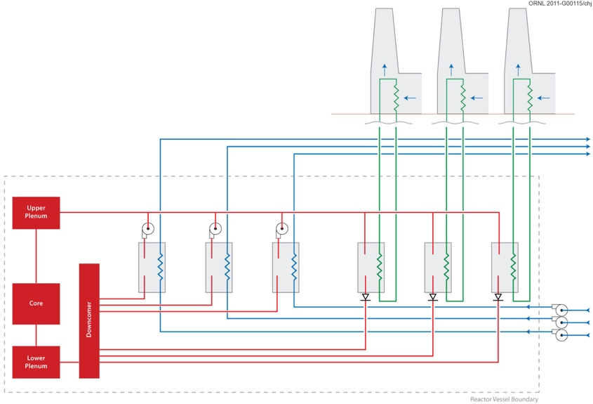
Fig. 1. Figure caption.

REFERENCES (optional; not included in the page count)
References must be single-column format, 11 point, Arial or Times New Roman.

